AI-powered Structural Health Monitoring (SHM) using seismic/vibration measurements

The basic idea:-
Buildings constantly face tiny movements related to wind, traffic, earthquakes etc which is impossible to be detected by human eye.

For that we use sensors to detect these movements. Then an AI/computational system learns what the building's normal vibration signature looks like.
It will report unusual vibrations and movements.

[MIT's research specifically explored using vibration measurements to infer structural condition and detect damage. Their Green Building experiment used 36 accelerometers distributed from the foundation to the roof.]

Seismic meter
The simplest version if a Seismic meter
is an accelerometer. An accelerometer measures acceleration along one or more axes. Provides results in form of a time varying signal.
This sensor doesn’t visually view the cracks and aftermath of the unusual vibrations it just detects the change in the usual format.
[we need to use multiple Seismic meter
around the building for more accurate output]

Work of AI:
AI looks at the vibration data collected by the sensors and learns what the building normally vibrates like. If the vibration pattern suddenly changes, the AI can detect it as an anomaly, which may mean the building has been damaged or has developed cracks.

Visualizing the cracks formed:
The camera captures images of the structure to detect visible cracks or damage. When the vibration sensor detects an unusual change, it can trigger the camera to take a picture, which is then analyzed by AI to identify cracks.

Training the AI model:
The AI learns the building’s normal vibration patterns from sensor data. When new data is different from the normal pattern, it can identify it as an anomaly and warn about possible damage.
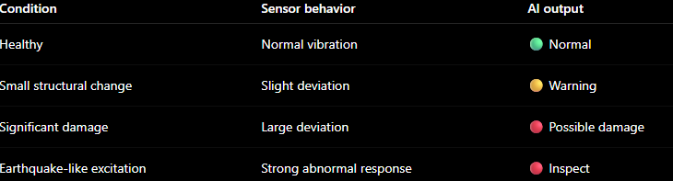

Physical prototype:
The physical prototype would be a small model building or bridge fitted with vibration sensors/accelerometers at different points. A motor or controlled shaking mechanism can simulate vibrations or earthquake-like movement. If the sensors detect unusual vibrations, a camera captures the structure, and the AI analyzes the data and images to identify possible damage or cracks. The results can be displayed on a laptop/dashboard as Normal, Warning, or Damage Detected.

Complete process:
The sensors/accelerometers attached to the structure detect vibrations and send the data to a microcontroller. The AI analyzes the vibration pattern and compares it with the structure’s normal behavior. If an unusual vibration is detected, it triggers a camera to capture the structure. The AI then analyzes the image for visible cracks or damage. Finally, the system combines the sensor and camera results and displays whether the structure is Normal, Needs Inspection, or Possibly Damaged.
Branch wise role:
EEE: Handles the accelerometers/sensors, circuits, power supply, microcontroller, and sensor data collection.
CSE: Handles programming, data transmission, database, dashboard, and communication between the components.
AI: Develops the AI models that analyse vibration data and camera images to detect abnormalities and cracks.
Civil: Designs the physical structure/model, decides sensor placement, and interprets what the detected vibrations and cracks mean structurally.

